System Requirements Statement (SRS) –

Online Intercity car pooling system

Doc. Ref. :

Version : 0.4

Status : Drafted

Created by : Kenji Tanaka

Date : 04-Dec-2012

1. Introduction 3

2. Functional Requirements 4

2.1 Car Owner Module 5

2.2 User Module 11

2.3 admin Module 17

2.4 message acknoeledgement Module 21

2.5 Use Case Diagram.............................................................................................................................22

THIS DOCUMENT CONTAINS 23 NUMBERED PAGES

# Introduction

This document explains the system requirements and scope for developing Online Inter -City Car Pooling System.

Online Inter-city Car Pooling System could divide the four main parts, Car-owner part, User part, Admin part and the acknowledgement part.

This document describes the system requirement of the Account part.

# Functional Requirements

The Account part of Online Intercity Car Pooling System has three modules which are divided 13 processes described as below.

|  |  |  |
| --- | --- | --- |
| **No** | **BRS requirement ID** | **Description** |
| **2.1** | **Car Owner Module** | |
| **2.1.1** | **F1** | **Account Creation Process** |
| **2.1.2** | **F2** | **Login Process** |
| **2.1.3** | **F3** | **Forgot Password Process** |
| **2.1.4** | **F4** | **Change Password Process** |
| **2.1.5** | **F5** | **Update Account Process** |
| **2.1.7** | **F7** | **Publish Ride** |
| **2.1.8** | **F8** | **Update Ride Information** |
| **2.1.9** | **F9** | **Delete Ride** |
| **2.2** | **User Module** | |
| **2.2.1** | **F10** | **Account Creation Process** |
| **2.2.2** | **F11** | **Login Process** |
| **2.2.3** | **F12** | **Forgot Password Process\*** |
| **2.2.4** | **F13** | **Change Password Process\*** |
| **2.2.5** | **F14** | **Update Account Process** |
| **2.2.6** | **F15** | **Search Ride** |
| **2.2.7** | **F16** | **Book Ride** |
| **2.2.8** | **F17** | **Payment Process** |
| **2.2.9** | **F18** | **Cancel Ride** |
| **2.3 Admin Module** | | |
| **2.3.1** | **F19** | **Login Process** |
| **2.3.2** | **F20** | **Forgot Password Process** |
| **2.3.3** | **F21** | **Change Password Process** |
| **2.3.4** | **F22** | **Update Account Process** |
| **2.3.5** | **F23** | **Report Generation** |
| **2.3.6** | **F24** | **Account Management** |
| **2.4 Message Acknowledgement Module** | | |
| **2.4.1** | **F25** | **Sends Messages of Acknowledgement** |

## Car Owner Module

* Car owner is the user of system who wants to create ride.

### Account Creation Process

* Online Intercity Car Pooling System compels to create the account before using it. So, Online Intercity Car Pooling system should provide the function which makes Car owner creates new account.
* When car owner creates new account, the function demands three information described as below.

1. Login information
2. Contact Details
3. Verification Details

* The Login information

The Login information consists of some items described as below.

1. UserID
2. Password
3. First Name
4. Last Name
5. E-mail address
6. Gender
   * All items are compulsory demanded.
   * UserID

* The UserID should be unique. If the UserID correspond with not case-sensitive to other which is previously registered, the UserID should not be registered as an account.
  + Password
* The Password has constrains which makes the Password consists of more than or equal 8 and less than or equal 16 characteristics including characters described as below.

1. Numeric figure (at least one)
2. Capital alphabet (A-Z)(at least one)
3. Small alphabet (a-z)(at least one)
4. Special character (#, $, %, &, etc.) (at least one)

* The Password is masked by dummy characters. The re-entering Password is demanded.
* The Password must be encrypted in Online Intercity Car Pooling System.
  + Gender

The User Type falls into three categories described as below.

1. Male
2. Female
3. Transgender

* Contact Details
* The Contact Detail consists of some items described as below.

1. Permanent Address
2. Contact Phone No
   * All items are compulsory demanded.
   * Permanent Address

* Permanent Address should be filled.
* But only the state should be selected from options.
* Verification Details
* The Verification Detail consists of some items described as below.

1. Aadhar Card
2. Driving License
3. Car Registration Details

* All items are compulsory demanded.
* The Security Question information

The Security Question information is needed when Car Owner lost their Password. This information consists of two items described as below.

1. Selected Question
2. Answer
   * All items are compulsory demanded.
   * Some questions which are difficult to answer for anyone else are prepared in advance.

E.g. which color do you like most?

* + A question should be selected from options by the Car Owner, and the Answer is registered by the Car Owner.
* Login information should be entered on one screen, and then Car-owner information and Security Question information should be entered on another screen.

### Login Process

* Online Intercity car Pooling System always compels Car Owner authentication before using itself except when a new account is successfully created.
* The user authentication demands UserID and Password. The UserID and the Password should be checked in three ways.
  + First, The UserID and the Password should be existed and correct.
* If The UserID and the Password are not equal to what the user has registered, the user authentication cannot be provided.
  + Finally, UserID should be available.
* The Administrator can decide whether the UserID is available or suspended – Refer to the SRS of the Admin part.
* If Car Owner is rejected, user authentication is not provided for system user.
* The Car Owner account should alive for so long as the duration decided by Admin.
* Only when the two checks are successfully completed, Car Owner can be placed on respected page.
* The “Car Owner Home” provides the some items described as below.

1. A trigger to logout
2. A trigger to update Account
3. A trigger to Change Password
4. A trigger to Create Ride
5. A trigger to Update Ride Information
6. A trigger to Delete Ride

### Forgot Password Process

* When system user lost their Password, the recovery method should be provided by Online Intercity Car Pooling System.

The recovery method is described as below.

* + First, system user enters their UserID for Online Intercity Car Pooling System.
  + Next, Online Intercity Car Pooling System demands the Answer which has been registered since when the Account was created.
  + Only when the Answer is correct, Owner get the new password by E-mail which also has been registered since when the Account was created.
  + The new password is automatically generated by Online Intercity Car Pooling System.
* Of course, the new password should consist of more than or equal 8 and less than or equal 16 characteristics including at least a numeric figure, a capital alphabet, a small alphabet, and a special character.
* As a consequence, The Car-owner could get the Car-owner authentication using the new password.
  + Then, the Car-owner had better change the new password manually.
* If the Answer is not correct, otherwise, the correct Answer is demanded for user again.
  + In that case, Of course, Car-owner couldn’t get the new password.

### Change Password Process

* When Car-owner wants to change their Password, the measure should be provided by Online Intercity Car Pooling System.
* Therefore, Online Intercity Car Pooling System should provide the function which is available after getting the Car-owner authentication.
* The function demands the current password and the new password.
  + Of course, the new password should consist of more than or equal 8 and less than or equal 16 characteristics including at least a numeric figure, a capital alphabet, a small alphabet, and a special character.
  + The current password and the new password are masked by using dummy characters.
  + The new password is demanded to enter twice to avoid a typing error.
* Only when the current password is correct, Car-owner could change their Password.
* When the current password is changed into new password, Online Intercity Car Pooling System compels user authentication again.

### Update Account Process

* Online Intercity Car Pooling System should provide the function which makes the account updated for Car-owner.
* The information Car-owner could update is described below.

1. Login information
2. User information
3. Security Question Information

* The Login information

The updatable items as described below.

1. First Name
2. Last Name
3. E-mail address
   * All items are compulsory demanded, but updating is optional.

* The User information

The updatable items as described below.

1. User Name
2. User Phone No
3. E-mail address
4. Permanent address
   * All items are compulsory demanded, but updating is optional.

* The Security Question information

The updatable items as described below.

1. Selected Question
2. Answer
   * All items are compulsory demanded, but updating is optional.

### 2.1.6 Publish ride

* Publish ride requirements are described as below.

1. Information of ride.
2. price
3. Seats available.
4. Photos.

### 2.1.7 Update ride information

* After publishing the ride the Car-owner can only update following contents.

1. About time date and place.
2. About seat availability.
3. Cancelation of ride before 12 hours.

### 2.1.8 Delete ride

• After Publishing ride if Car-owner have some emergency or wanted to not go their destination, he will update ride information before 12 hours then he can delete the ride.

#### User Module

### Account Creation Process

* Online Intercity Car Pooling System compels to create the account before using it. So Online Intercity Car Pooling System should provide the function which makes user creates new account.
* When user creates new account, the function demands four information described as below.

1. Login information

2.Contact Details

3.Security Question Information

4.Payment information.

* The Login information

The Login information consists of some items described as below.

1.UserID

2.Password

3.First Name

4.Last Name

5.E-mail address

6.Gender

* + All items are compulsory demanded.
  + UserID
* The UserID should be unique. If the UserID correspond with not case-sensitive to other which is previously registered, the UserID should not be registered as an account.
  + Password
* The Password has constrains which makes the Password consists of more than or equal 8 and less than or equal 16 characteristics including characters described as below.

1.Numeric figure (at least one)

2.Capital alphabet (A-Z)(at least one)

3.Small alphabet (a-z)(at least one)

4.Special character (#, $, %, &, etc.) (at least one)

* The Password is masked by dummy characters. The re-entering Password is demanded.
* The Password must be encrypted in Online Intercity Car Pooling System.
  + Gender

The User Type falls into three categories described as below.

1.Male

2.Female

3.Transgender

* Contact Details
* The Contact Detail consists of some items described as below.

1.Permanent Address

2.Contact Phone No

* + All items are compulsory demanded.
  + Permanent Address
* Permanent Address should be filled.
* But only the state and city should be selected from options.
* The Security Question information

The Security Question information is needed when User lost their Password. This information consists of two items described as below.

1. Selected Question
2. Answer
   * All items are compulsory demanded.
   * Some questions which are difficult to answer for anyone else are prepared in advance.

E.g. which color do you like most?

* + A question should be selected from options by the user, and the Answer is registered by the user.
* Login information should be entered on one screen, and then user information and Security Question information should be entered on another screen.

### Login Process

* Online Intercity Car Pooling System always compels authentication before using itself except when a new account is successfully created.
* The user authentication demands UserID and Password. The UserID and the Password should be checked in three ways.
  + First, The UserID and the Password should be existed and correct.
* If The UserID and the Password are not equal to what the user has registered, the user authentication cannot be provided.
  + Second, the User Type linked to the UserID should be "user".
  + Finally, UserID should be available.
* The Administrator can decide whether the UserID is available or suspended – Refer to the SRS of the Admin part.
* The User account should alive for so long as the duration decided by Admin.
* Only when the three checks are successfully completed, user can be placed on respected page.
* The “User Home” provides the some items described as below.

1. A trigger to logout
2. A trigger to update Account
3. A trigger to Change Password
4. A trigger to Search Ride
5. A trigger to Book ride
6. A trigger to Update Ride Information
7. A trigger to Delete Ride

### Forgot Password Process

* When User lost their Password, the recovery method should be provided by Online Intercity Car Pooling system.

The recovery method is described as below.

* + First, User enters their UserID for e-Farming System.
  + Next, Online Intercity Car Pooling System demands the Answer which has been registered since when the Account was created.
  + Only when the Answer is correct, User get the new password by E-mail which also has been registered since when the Account was created.
  + The new password is automatically generated by Online Intercity Car Pooling System.
* Of course, the new password should consist of more than or equal 8 and less than or equal 16 characteristics including at least a numeric figure, a capital alphabet, a small alphabet, and a special character.
* As a consequence, The User could get the user authentication using the new password.
  + Then, the User r had better change the new password manually.
* If the Answer is not correct, otherwise, the correct Answer is demanded for User again.
  + In that case, Of course, User couldn’t get the new password.

### Change Password Process

* When User wants to change their Password, the measure should be provided by Online Intercity Car Pooling System.
* Therefore Online Intercity Car Pooling System should provide the function which is available after getting the User authentication.
* The function demands the current password and the new password.
  + Of course, the new password should consist of more than or equal 8 and less than or equal 16 characteristics including at least a numeric figure, a capital alphabet, a small alphabet, and a special character.
  + The current password and the new password are masked by using dummy characters.
  + The new password is demanded to enter twice to avoid a typing error.
* Only when the current password is correct, User could change their Password.
* When the current password is changed into new password, Online Intercity Car Pooling System compels User authentication again.

### Update Account Process

* Online Intercity Car Pooling System should provide the function which makes the account updated for User.
* The information user could update is described below.

1. Login information

2. Contact information

3. Security Question Information

* The Login information

The updatable items as described below.

* + - 1. First Name
      2. Last Name
      3. Email Address
  + All items are compulsory demanded, but updating is optional.
* The User information

The updatable items as described below.

1. User Name
2. User Phone No
3. E-mail address
4. Permanent address
   * All items are compulsory demanded, but updating is optional.

* The Security Question information

The updatable items as described below.

1. Selected Question
2. Answer
   * All items are compulsory demanded, but updating is optional.

#### Search Ride

• Search conditions are described as below.

1. Destination City
2. Starting Ride City
3. Price Range

• As the result of searching Requirements, User could see the list of rides which are available .

1. Car Owner Name

2. Price

3. Destination city

4. Ride Starting Location

5. Available Seats

#### Book Ride

• To book the ride followings are the condition

1. Destination city

2. Price range

3. No. of seats

4. Other detalis

**2.2.8 Payment Process**

• In payment process system following are the conditions

1. If somehow ride is not fulfil.

2. If user is not satisfied with ride.

**2.2.9 Cancel Order**

• User can cancel the ride in following condition

1. If the Car Owner does not fulfil the requirement.

2. If price goes out of his budget.

Browse existing product Price

• User could see the information of existing Rides**.**

#### Admin Module

**•** Administratorshould be responsible for following activities**,**

### Login Process

* Online Intercity Car Pooling System always compels user authentication before using itself except when a new account is successfully created.
* The user authentication demands UserID and Password. The UserID and the Password should be checked in three ways.
  + First, The UserID and the Password should be existed and correct.
* If The UserID and the Password are not equal to what the admin has registered, the Admin authentication cannot be provided.
  + Second, the User Type linked to the UserID should be "Admin".
* When the User Type is "Admin", user can be placed on “Admin Home”.
  + Finally, UserID should be available.
* The Administrator can decide whether the UserID is available or suspended – Refer to t
* .0he SRS of the Admin part.
* If user is rejected, user authentication is not provided for system user.
* The Admin account should alive for so long as the duration decided by Admin.
* Only when the three checks are successfully completed, Admin can be placed on respected page.
* The “Admin Home” provides the some items described as below.

1. A trigger to logout
2. A trigger to update Account
3. A trigger to Search Car Owner or User
4. A trigger to Update Car Owner or User Information
5. A trigger to Delete Car Owner or User Account

### Forgot Password Process

* When Admin lost their Password, the recovery method should be provided by Online Intercity Car Pooling System.

The recovery method is described as below.

* + First, Admin enters their UserID for Online Intercity Car Pooling System.
  + He will enter the E-mail id since when the Account was created.
  + Only when the E-mail Id is correct, Admin get the new password by E-mail which also has been registered since when the Account was created.
  + The new password is automatically generated by Online Intercity Car Pooling System.
* Of course, the new password should consist of more than or equal 8 and less than or equal 16 characteristics including at least a numeric figure, a capital alphabet, a small alphabet, and a special character.
* As a consequence, The Admin could get the Admin authentication using the new password.
  + Then, the Admin had better change the new password manually.

### Change Password Process

* When Admin wants to change his Password, the measure should be provided by Online Car Pooling System.
* Therefore, Online Intercity Car Pooling System should provide the function which is available after getting the Admin authentication.
* The function demands the current password and the new password.
  + Of course, the new password should consist of more than or equal 8 and less than or equal 16 characteristics including at least a numeric figure, a capital alphabet, a small alphabet, and a special character.
  + The current password and the new password are masked by using dummy characters.
  + The new password is demanded to enter twice to avoid a typing error.
* Only when the current password is correct, Admin could change his Password.
* When the current password is changed into new password, Online Intercity Car Pooling System compels user authentication again.

### Update Account Process

* Online Intercity Car Pooling System should provide the function which makes the account updated for Admin.
* The information Admin could update is described below.

1. Login information
2. User information
3. Security Question Information

* The Login information

The updatable items as described below.

1. First Name
2. Last Name
3. E-mail address
   * All items are compulsory demanded, but updating is optional.

* The User information

The updatable items as described below.

1. User Name
2. User Phone No
3. E-mail address
4. Permanent address
   * All items are compulsory demanded, but updating is optional.

* The Security Question information

The updatable items as described below.

1. Selected Question
2. Answer
   * All items are compulsory demanded, but updating is optional.

#### Record Generation

• Admin should able to see all the records from any users.

• Daily report of enrolment to admin.

• Monthly report of enrolment as per the states to admin.

#### Accounts Management

• Admin should able to manage all the accounts with following activities,

1. Enable accounts

2. Disable accounts

#### Message Acknowledgement Module

• In following conditions acknowledgement to be send

1. After completion of successful registration.
2. After every successful transaction (buy, sale).
3. Now the messages are being sent by using email but in future we can have mobile sms.

#### 2.5 Use Case Diagram

**Admin:**

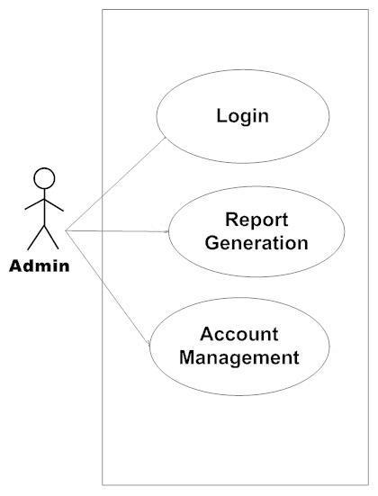

*Fig. Use case diagram for admin*

1. In Admin use case diagram Admin is the Actor.
2. Admin can handle following use cases:
3. Login
4. Report Generation
5. Controls account

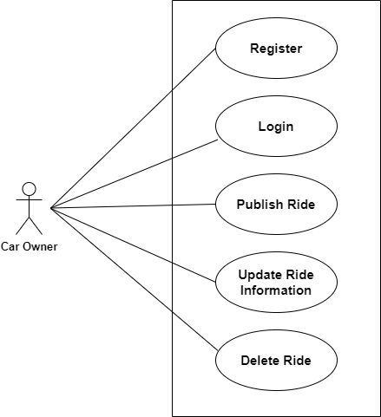

*Fig. Use case diagram for Car Owner*

**Car Owner:**

1. In Car Owner use case diagram Car Owner is the Actor.
2. Farmer can handle following use cases:
3. Register
4. Login
5. Publish Ride
6. Update Ride Information
7. Delete Ride

**User:**

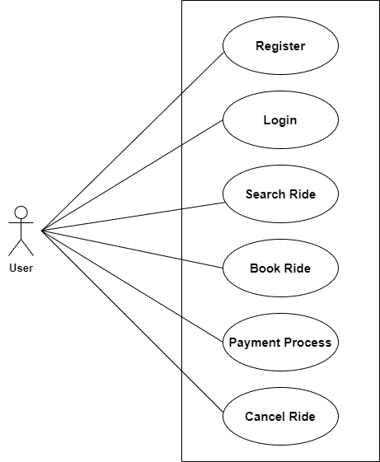

*Fig. Use case diagram for User*

1. In User use case diagram User is the Actor**.**
2. User can handle following use cases:
3. Register
4. Login
5. Search Ride
6. Book Ride
7. Payment Process
8. Cancel Ride